Running Head: GENERALIZED KAPPA STATISTIC

Software Solutions for Obtaining a Kappa-Type Statistic
for Use with Multiple Raters
Jason E. King
Baylor College of Medicine

Paper presented at the annual meeting of the Southwest Educational Research Association, Dallas, Texas, Feb. 5-7, 2004.
Correspondence concerning this article should be addressed to Jason King, 1709 Dryden Suite 534, Medical Towers, Houston, TX. 77030. E-mail: Jasonk@bcm.tmc.edu

Abstract

Many researchers are unfamiliar with extensions of Cohen’s kappa for assessing the interrater reliability of more than two raters simultaneously. This paper briefly illustrates calculation of both Fleiss’ generalized kappa and Gwet’s newly-developed robust measure of multi-rater agreement using SAS and SPSS syntax. An online, adaptable Microsoft Excel spreadsheet will also be made available for download.

Theoretical Framework

Cohen’s (1960) kappa statistic (κ) has long been used to quantify the level of agreement between two raters in placing persons, items, or other elements into two or more categories. Fleiss (1971) extended the measure to include multiple raters, denoting it the generalized kappa statistic,¹ and derived its asymptotic variance (Fleiss, Nee, & Landis, 1979). However, popular statistical computing packages have been slow to incorporate the generalized kappa. Lack of familiarity with the psychometrics literature has left many researchers unaware of this statistical tool when assessing reliability for multiple raters. Consequently, the educational literature is replete with articles reporting the arithmetic mean for all possible paired-rater kappas rather than the generalized kappa. This approach does not make full use of the data, will usually not yield the same value as that obtained from a multi-rater measure of agreement, and makes no more sense than averaging results from multiple t tests rather than conducting an analysis of variance.
Two commonly cited limitations of all kappa-type measures are their sensitivity to raters’ classification probabilities (marginal probabilities) and trait prevalence in the subject population (Gwet 2002c). Gwet (2002b) demonstrated that statistically testing the marginal probabilities for homogeneity does not, in fact, resolve these problems. To counter these potential drawbacks, Gwet (2001) has proposed a more robust measure of agreement among multiple raters, denoting it the AC₁ statistic. This statistic can be interpreted similarly to the generalized kappa, yet is more resilient to the limitations described above.
A search of the Internet revealed no freely-available algorithms for calculating either measure of inter-rater reliability without purchase of a commercial software package. Software options do exist for obtaining these statistics via the commercial packages, but they are not typically available in a point-and-click environment and require use of macros.
The purpose of this paper is to briefly define the generalized kappa and the AC₁ statistic, and then describe their acquisition via two of the more popular software packages. Syntax files for both the Statistical Analysis System (SAS) and the Statistical Package for the Social Sciences (SPSS) are provided. In addition, the paper describes an online, freely-available Microsoft Excel spreadsheet that estimates the generalized kappa statistic, its standard error (via two options), statistical tests, and associated confidence intervals. Application of each software solution is made using a real dataset. The dataset consists of three expert physicians having categorized each of 45 continuing medical education (CME) presentations into one of six competency areas (e.g., medical knowledge, systems-based care, practice-based care, professionalism). For purposes of replication, the data are provided in Table 1.

Generalized Kappa Defined

Kappa is a chance-corrected measure of agreement between two raters, each of whom independently classifies each of a sample of subjects into one of a set of mutually exclusive and exhaustive categories. It is computed as

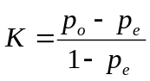, (1)

where 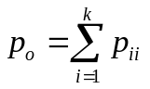, 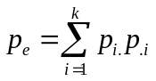, and p = the proportion of ratings by two raters on a scale having k categories.
Fleiss’ extension of kappa, called the generalized kappa, is defined as

, (2)

where k = the number of categories, n = the number of subjects rated, m = the number of raters, 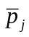 = the mean proportion for category j, and 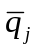 = 1 – the mean proportion for category j. This index can be interpreted as a chance-corrected measure of agreement among three or more raters, each of whom independently classifies each of a sample of subjects into one of a set of mutually exclusive and exhaustive categories.
As mentioned earlier, Gwet suggested an alternative to the generalized kappa, denoted the AC1 statistic, to correct for kappa’s sensitivity to marginal probabilities and trait prevalence. See Gwet (2001) for computational details.
A technical issue that should be kept in mind is the lack of consensus on the correct standard error formula to employ. Fleiss’ (1971) original standard error formulas is as follows:

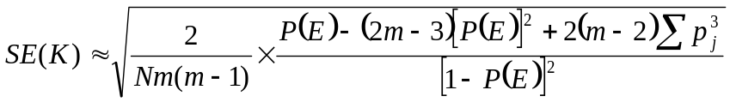, (3)

where and . Fleiss, Nee, and Landis (1979) corrected the standard error formula to be

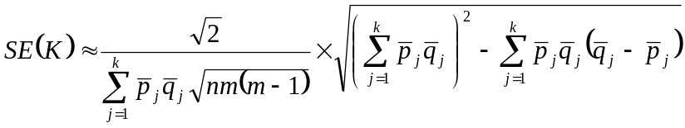. (4)

The latter formula produces smaller standard error values than the original formula.
Regarding usage, algorithms employed in the computing packages may use either formula. Gwet (2002a) mentioned in passing that the Fleiss et al. (1979) formula used in the MAGREE.SAS macro (see below) is less accurate than the formula used in his macro (i.e., Fleiss’ SE formula). However, it is unknown why Gwet would prefer Fleiss’ original formula to the (ostensibly) more accurate revised formula.

Generalized Kappa Using SPSS Syntax

David Nichols at SPSS developed a macro to be run through the syntax editor permitting calculation of the generalized kappa, a standard error estimate, test statistic, and associated probability. The calculations for this macro, entitled MKAPPASC.SPS (available at ftp://ftp.spss.com/pub/spss/statistics/nichols/macros/mkappasc.sps), are taken from Siegel and Castellan (1988). Siegel and Castellan employ equation 3 to calculate the standard error.
The SPSS dataset should be formatted such that the number of rows = the number of items being rated; the number of columns = the number of raters, and each cell entry represents a single rating. The macro is invoked by running the following command:

MKAPPASC VARS=rater1 rater2 rater3.

The column names of the raters should be substituted for rater1, rater2, and rater3. Results for the sample dataset are as follows:

Matrix

Run MATRIX procedure:

------ END MATRIX -----

Report

Estimated Kappa, Asymptotic Standard Error,
and Test of Null Hypothesis of 0 Population Value

Kappa ASE Z-Value P-Value
___________ ___________ ___________ ___________

.28204658 .08132183 3.46827632 .00052381

Note that the limited results provided by the SPSS macro indicate that the kappa value is statistically significantly different from 0 (p < .001), but not large (k = .282).

Generalized Kappa Using SAS Syntax

SAS Technical Support has also developed a macro for calculating kappa, denoted MAGREE.SAS (available at http://ewe3.sas.com/techsup/download/stat/magree.html). That macro will not be presented here, however, a SAS macro developed by Gwet will be described. Gwet’s macro, entitled INTER_RATER.MAC, allows for calculation of both the generalized kappa and the AC1 statistic (available at http://ewe3.sas.com/techsup/download/stat/magree.html). Gwet’s macro also employs equation 3 to calculate the standard error. A nice feature of the macro is its ability to calculate both conditional and unconditional (i.e., generalizable to a broader population) variance estimates.
The SAS dataset should be formatted such that the number of rows = the number of items being rated; the number of columns = the number of raters, and each cell entry represents a single rating. A separate one variable data set must be created defining the categories available for use in rating the subjects (see an example available at http://www.ccit.bcm.tmc.edu/jking/homepage/).
The macro is invoked by running the following command:

%Inter_Rater(InputData=a,
DataType=c,
VarianceType=c,
CategoryFile=CatFile,
OutFile=a2);

Variance type can be modified to u rather than c if unconditional variances are desired. Results for the sample data are as follows:

INTER_RATER macro (v 1.0)
Kappa statistics: conditional and unconditional analyses

Standard
Category Kappa Error Z Prob>Z

1 0.28815 0.21433 1.34441 0.08941
2 0.21406 0.29797 0.71841 0.23625
3 -0.03846 0.27542 -0.13965 0.55553
4 . . . .
5 0.49248 0.38700 1.27256 0.10159
6 0.47174 0.21125 2.23311 0.01277
Overall 0.28205 0.08132 3.46828 0.00026

INTER_RATER macro (v 1.0)
AC1 statistics: conditional and unconditional analyses
Inference based on conditional variances of AC1

AC1 Standard
Category statistic Error Z Prob>Z

1 0.37706 0.19484 1.93520 0.02648
2 0.61643 0.12047 5.11695 0.00000
3 -0.13595 0.00000 . .
4 . . . .
5 0.43202 0.56798 0.76064 0.22344
6 0.48882 0.25887 1.88831 0.02949
Overall 0.51196 0.05849 8.75296 0.00000

Note that the kappa value and SE are identical to those obtained earlier. This algorithm also permits calculation of kappas for each rating category. It is of interest to observe that the AC1 statistic yielded a larger value (.512) than kappa (.282). This reflects the sensitivity of kappa to the unequal trait prevalence in the populations (notice in the Table 1 data that few presentations were judged as embracing competencies 3, 4 and 5).

Generalized Kappa Using a Microsoft Excel Spreadsheet

To facilitate more widespread use of the generalized kappa, the author developed a Microsoft© Excel spreadsheet that calculates the generalized kappa, kappa values for each rating category (along with associated standard error estimates), overall standard error estimates using both Equations 3 and 4, test statistics, associated probability values, and confidence intervals (available for download at http://www.ccit.bcm.tmc.edu/jking/homepage/). To the author’s knowledge, such a spreadsheet is not available elsewhere.
Directions are provided on the spreadsheet for entering data. Edited results for the sample data are provided below:

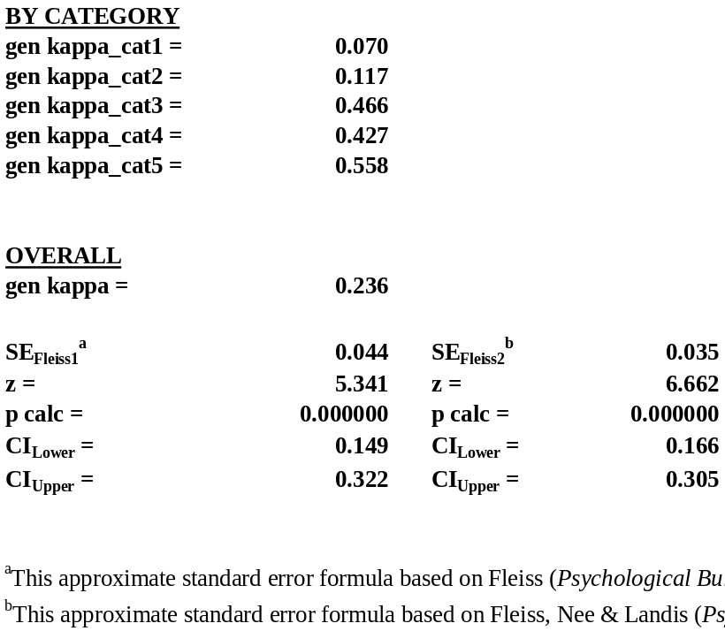

Again, the kappa value is identical to that obtained earlier, as is the SE estimate based on Fleiss (1971). Fleiss et al.’s (1979) revised SE estimate is slightly lower and yields tighter confidence intervals. Use of confidence intervals permits assessing a range of possible kappa values, rather than making dichotomous decisions concerning interrater reliability. This is in keeping with current best practices (e.g., Fan & Thompson, 2001).

Conclusion

Fleiss’ generalized kappa is useful for quantifying interrater agreement among three or more judges. This measure has not been incorporated into the point-and-click environment of the major statistical software packages, but can easily be obtained using SAS code or SPSS syntax. An alternative approach is to use a newly-developed Microsoft Excel spreadsheet.

Footnote
¹Gwet (2002a) notes that Fleiss’ generalized kappa was based not on Cohen’s kappa but on the earlier pi (π) measure of inter-rater agreement introduced by Scott (1955).

References

Cohen, J. (1960). A coefficient of agreement for nominal scales. Educational and Psychological Measurement, 20, 37-46.
Fan, X., & Thompson, B. (2001). Confidence intervals about score reliability coefficients, please: An EPM guidelines editorial. Educational and Psychological Measurement, 61, 517-531.
Fleiss, J. L. (1971). Measuring nominal scale agreement among many raters. Psychological Bulletin, 76, 378-382.
Fleiss, J. L. (1981). Statistical methods for rates and proportions (2nd ed.). New York: John Wiley & Sons, Inc.
Fleiss, J. L., Nee, J. C. M., & Landis, J. R. (1979). Large sample variance of kappa in the case of different sets of raters. Psychological Bulletin, 86, 974-977.
Gwet, K. (2001). Handbook of inter-rater reliability. STATAXIS Publishing Company.
Gwet, K. (2002a). Computing inter-rater reliability with the SAS system. Statistical Methods for Inter-Rater Reliability Assessment Series, 3, 1-16.
Gwet, K. (2002b). Inter-rater reliability: Dependency on trait prevalence and marginal homogeneity. Statistical Methods for Inter-Rater Reliability Assessment Series, 2, 1-9.
Gwet, K. (2002c). Kappa statistic is not satisfactory for assessing the extent of agreement between raters. Statistical Methods for Inter-Rater Reliability Assessment Series, 1, 1-6.
Siegel, S., & Castellan, N. J. (1988). Nonparametric Statistics for the Behavioural Sciences (2nd ed.). New York: McGraw-Hill.
Scott, W. A. (1955). Reliability of content analysis: The case of nominal scale coding. Public Opinion Quarterly, XIX, 321-325.

Table 1

Physician Ratings of Presentations Into Competency Areas

Subject | Rater1 | Rater2 | Rater3 |  | Subject | Rater1 | Rater2 | Rater3
1 | 1 | 1 | 1 |  | 24 | 2 | 2 | 6
2 | 2 | 1 | 2 |  | 25 | 2 | 6 | 6
3 | 2 | 2 | 2 |  | 26 | 6 | 1 | 1
4 | 2 | 1 | 1 |  | 27 | 6 | 6 | 6
5 | 2 | 1 | 2 |  | 28 | 2 | 6 | 6
6 | 2 | 1 | 2 |  | 29 | 2 | 6 | 6
7 | 2 | 2 | 1 |  | 30 | 6 | 6 | 1
8 | 2 | 1 | 2 |  | 31 | 6 | 6 | 6
9 | 2 | 1 | 2 |  | 32 | 2 | 5 | 5
10 | 2 | 1 | 1 |  | 33 | 2 | 3 | 2
11 | 2 | 1 | 3 |  | 34 | 2 | 2 | 2
12 | 2 | 2 | 1 |  | 35 | 2 | 2 | 2
13 | 2 | 2 | 2 |  | 36 | 2 | 6 | 6
14 | 2 | 2 | 2 |  | 37 | 2 | 2 | 6
15 | 2 | 1 | 1 |  | 38 | 2 | 2 | 2
16 | 2 | 1 | 1 |  | 39 | 2 | 2 | 2
17 | 2 | 2 | 3 |  | 40 | 2 | 2 | 2
18 | 2 | 1 | 6 |  | 41 | 2 | 2 | 3
19 | 2 | 2 | 3 |  | 42 | 2 | 2 | 2
20 | 1 | 1 | 1 |  | 43 | 2 | 2 | 2
21 | 2 | 2 | 2 |  | 44 | 2 | 2 | 2
22 | 2 | 1 | 2 |  | 45 | 2 | 1 | 2
23 | 1 | 1 | 1

Back to Jason King's Homepage

